SPANISH OMELLETE
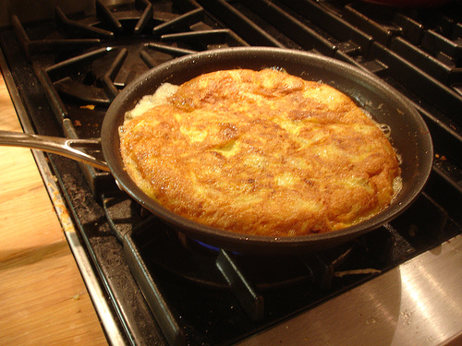

ARNAU HUGUET GENÉ
- Age: 12 years old.
- City: Lleida (Spain).
- School and class: IES Màrius Torres 1st ESO C.

FRANCESC AGUSTÍ MORELL
- Age: 12 years old.
- City: Lleida (Spain).
- School and class: IES Màrius Torres 1st ESO C.

INGREDIENTS:
- 4 eggs
- 1/2 kilo potatoes
- Olive oil (one glass, or 1/4 litre)
- Salt
- Onions (optional)

Recommendations: Always use quality ingredients then the omelette its better.

COOKING EQUIPMENT:
- A pan.
- A spatula.
- Some kitchen paper.
- A lid of the frying pan (or a large plate).

THE RECIPE

Preparation time | 10 minutes
Cooking time | 20 minutes
How difficult | Easy

STEPS:
- 1Wash and cut the potatoes into thin slices.
- Heat the oil in the pan, and add the potatoes and salt.
- Fry, and stir occasionally. Tip: If you prefer the potatoes to be soft, use a spatula to mash them as they are frying.
- When they are a golden colour, remove from the pan and put the potato mixture in a sieve or on kitchen paper, so that as much oil as possible drains away or is absorbed.
- Beat the eggs well with a pinch of salt, and add to the potatoes. Mix well.
- Put two small spoonfuls of olive oil in the frying pan

- Once the oil is hot, add the potato and egg mixture.

- When the omelette is cooked, use the lid of the frying pan (or a large plate) to tip the omelette out of the pan, add a little more oil and slide the omelette in again, this time putting the less cooked side first into the pan.

- If you need to repeat this step, so that the omelette is perfectly cooked and golden on both sides, you may do so. This omelette is delicious hot or cold.

Yum ! Yum Delicious

